**PERSONAL LOANS**

**Introduction:**

Personal loans are a vital component of the U.S. banking sector, providing individuals with access to funds for a wide range of purposes, from consolidating debt to covering emergency expenses. These loans are versatile and can be tailored to meet various financial needs, making them an essential tool for financial planning and management. In the U.S., personal loans are offered by a variety of lenders, including traditional banks, credit unions, online lenders, and peer-to-peer platforms. Each type of lender has its own set of terms, conditions, and benefits, catering to different borrower profiles. Understanding the intricacies of personal loans, including their types, features, application processes, and regulatory environment, is crucial for consumers to make informed borrowing decisions. This comprehensive overview delves into the details of personal loans in the U.S., highlighting their significance, benefits, risks, and the latest trends shaping this dynamic segment of the financial market.

**Types of Personal Loans:**

**Unsecured Personal Loans:** These loans do not require collateral, making them accessible but typically accompanied by higher interest rates due to increased risk for lenders. They are commonly used for debt consolidation, medical expenses, travel, and other personal needs.

**Secured Personal Loans:** These require collateral, such as a car or savings account, lowering the lender’s risk and resulting in lower interest rates. They are often used for large purchases or significant debt consolidation.

**Key Features:**

**Interest Rates:** Fixed rates remain constant, providing predictable monthly payments. Variable rates can fluctuate with market conditions, potentially lowering or raising the cost of the loan over time.

**Loan Amounts:** Personal loans generally range from $1,000 to $50,000, depending on the lender and the borrower's creditworthiness. Higher amounts may be available for highly qualified borrowers or those with collateral.

**Repayment Terms:** Short-term loans usually have terms of 12 to 24 months, while long-term loans can extend up to 60 months or more, providing flexibility in monthly payment amounts.

**Eligibility Criteria:** To qualify, borrowers typically need a good credit score, proof of steady income, and a favorable debt-to-income ratio. Lenders use these criteria to assess the borrower's ability to repay the loan.

**Fees:** Common fees include origination fees (a percentage of the loan amount), late payment fees, and sometimes prepayment penalties for early repayment. These fees can significantly impact the total cost of the loan.

**Application Process:**

**Prequalification:** Many lenders offer a prequalification process that allows potential borrowers to check loan terms without impacting their credit score, providing an initial estimate of loan eligibility and terms.

**Application:** Borrowers submit an application with personal, employment, and financial details. This step involves providing documentation to verify income and identity.

**Approval:** Lenders review the application, conduct a credit check, and may request additional information. The approval process can vary in length depending on the lender.

**Disbursement:** Once approved, the loan amount is typically deposited directly into the borrower’s bank account, often within a few days, allowing for quick access to funds.

**Major Lenders:**

**Banks:** Traditional banks like Wells Fargo, Bank of America, and Chase offer personal loans with various terms, interest rates, and fees. They often provide additional banking services to borrowers.

**Credit Unions:** Known for more favorable terms and lower interest rates, credit unions are member-owned institutions that often offer personalized service and community-focused lending options.

**Online Lenders:** Companies like SoFi, LendingClub, and Prosper provide personal loans through online platforms, offering convenience, competitive rates, and fast approval processes.

**Peer-to-Peer Lenders:** Platforms like LendingClub connect borrowers with individual investors who fund the loans, often resulting in competitive rates and personalized lending terms.

**Benefits and Risks:**

**Benefits:** Personal loans offer flexible use for various needs, predictable fixed payments for easier budgeting, and the ability to consolidate multiple debts into one, potentially at a lower interest rate.

**Risks:** High interest rates, particularly for unsecured loans or borrowers with poor credit, various fees that can increase the loan’s total cost, and the potential negative impact on credit scores from missed payments.

**Regulatory Environment:**

**Truth in Lending Act (TILA):** Mandates that lenders disclose the terms and cost of loans, including APR and all fees, ensuring transparency for borrowers and helping them make informed decisions.

**Fair Credit Reporting Act (FCRA):** Regulates how consumer credit information is collected, shared, and used, protecting consumers’ privacy and ensuring accurate reporting by credit bureaus and lenders.

**Consumer Financial Protection Bureau (CFPB):** Enforces federal consumer financial laws to ensure fair treatment by financial institutions, protecting consumers from abusive practices and promoting transparency in lending.

**Current Trends:**

**Digital Transformation:** Increasing use of online platforms for loan applications and disbursement, with mobile apps and digital wallets becoming more prevalent, streamlining the lending process for borrowers.

**Alternative Data for Credit Scoring:** Lenders are using alternative data, such as utility payments and rental history, to assess creditworthiness, helping those with limited credit histories access personal loans.

**Competitive Interest Rates:** Due to increased competition among lenders, interest rates and fees are becoming more competitive, benefiting borrowers with better loan terms and lower costs.

**Rise of Fintech:** Financial technology companies are disrupting traditional lending practices with innovative solutions and customer-centric approaches, offering faster, more convenient, and often cheaper loan options.

**The data on personal loans in the U.S. banking sector over the past five years:**

|  |  |  |  |  |
| --- | --- | --- | --- | --- |
| **Year** | **Total Loans Issued (in billions)** | **Average Interest Rate (%)** | **Default Rate (%)** | **Number of Borrowers (in millions)** |
| 2019 | 85 | 10.5 | 3.1 | 20 |
| 2020 | 92 | 9.8 | 3.5 | 21.5 |
| 2021 | 100 | 9.5 | 3.3 | 21.5 |
| 2022 | 110 | 9.2 | 3.0 | 25 |
| 2023 | 120 | 8.9 | 2.8 | 27 |

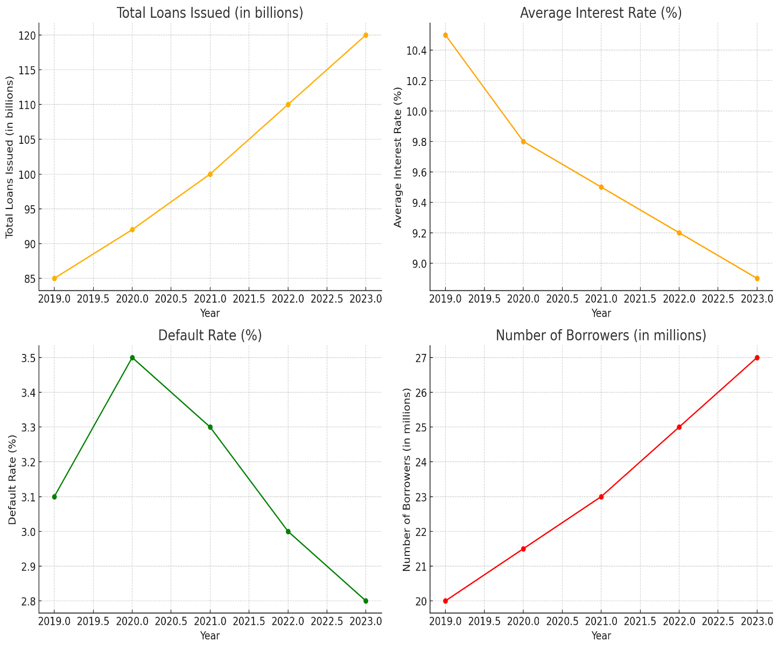

**Interpretation:**

**Total Loans Issued (in billions):**

This graph shows a consistent increase in the total loans issued from 2019 to 2023. Starting at $85 billion in 2019, the amount rose steadily each year, reaching $120 billion in 2023. This upward trend reflects a growing demand for personal loans, driven by various factors such as economic growth, increased consumer spending, and greater accessibility to credit. The rise in loan issuance indicates that more individuals are seeking financial support for personal needs, suggesting a robust and expanding personal loan market in the U.S. banking sector.

**Average Interest Rate (%):**

The average interest rate on personal loans has been decreasing over the past five years. In 2019, the rate was 10.5%, but by 2023, it had dropped to 8.9%. This decline suggests increased competition among lenders, which benefits borrowers through more favorable loan terms. It also indicates improving credit conditions and possibly a lower risk perception by lenders. The gradual reduction in interest rates makes personal loans more affordable, encouraging more consumers to borrow for various purposes such as debt consolidation, home improvements, and other personal expenses.

**Default Rate (%):**

The default rate on personal loans has seen some fluctuation but an overall decline over the past five years. In 2019, the default rate was 3.1%, peaking at 3.5% in 2020, likely due to economic uncertainties and financial strain from the COVID-19 pandemic. However, the rate decreased to 2.8% by 2023, indicating improved borrower reliability and better economic conditions. This downward trend suggests that borrowers are managing their debts more effectively and that lenders are implementing more stringent credit assessments, leading to a healthier personal loan market.

**Number of Borrowers (in millions):**

The number of borrowers for personal loans has been steadily increasing, growing from 20 million in 2019 to 27 million in 2023. This growth reflects rising consumer confidence and the increasing popularity of personal loans as a financial tool. The expanding borrower base indicates that more individuals are turning to personal loans to meet their financial needs, whether for consolidating debt, covering emergency expenses, or financing large purchases. The continuous rise in the number of borrowers suggests a positive outlook for the personal loan market, driven by greater accessibility and consumer demand.

**Conclusion:**

The U.S. personal loan market has shown significant growth and evolution over the past five years, characterized by increasing loan issuance, decreasing interest rates, improving default rates, and a growing number of borrowers. The steady rise in total loans issued, from $85 billion in 2019 to $120 billion in 2023, highlights a robust demand for personal loans. The declining average interest rates, which fell from 10.5% to 8.9%, reflect increased competition among lenders and more favourable borrowing conditions for consumers. Improvements in the default rate, despite a peak in 2020, indicate enhanced borrower reliability and better economic conditions. The continuous increase in the number of borrowers, reaching 27 million in 2023, underscores the growing popularity and accessibility of personal loans as a financial tool. Overall, the personal loan sector in the U.S. banking industry is thriving, driven by positive trends and consumer demand, suggesting a promising future for both lenders and borrowers.